**BT307 LAB 1**

**1) Name:** Aditya Jindal

**2) Roll No.:** 210106004

**3)** I am using data1.csv.

**4)**

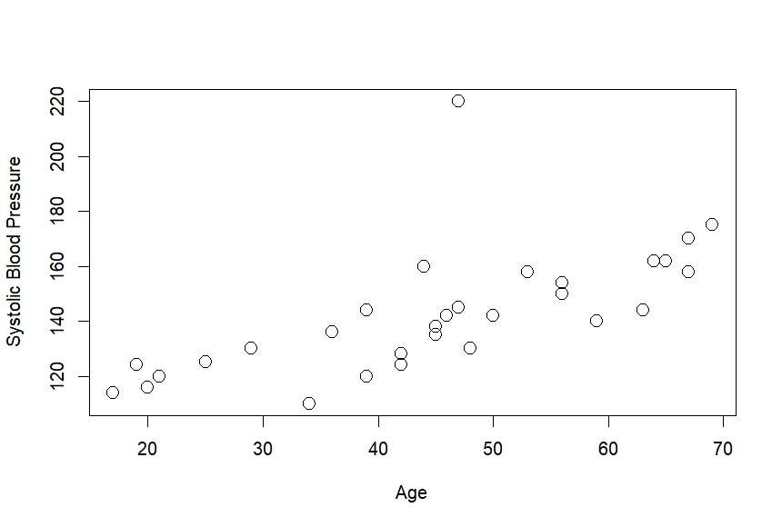

**5)** Pearson's correlation = 0.6575673

**6)** P-value = 7.867e-05

**7)** As the Pearson’s correlation is 0.65, it signifies a positive association between Age and Systolic Blood Pressure. P-value(7.867 x 10^(-5)) of less than 0.05 proves that this result is statistically significant and we reject the null hypothesis.